**Create a new Module and manifest file**

1.First follow below Directory Structure.

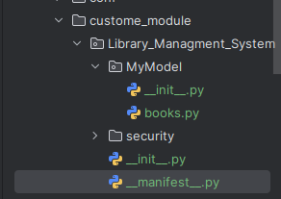

2.create __manifest__ file and __init__ file:

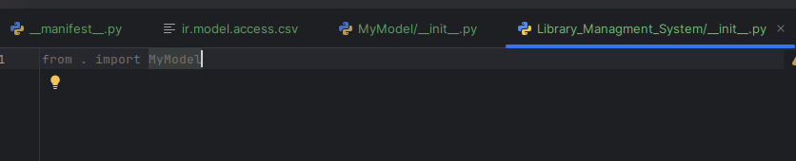

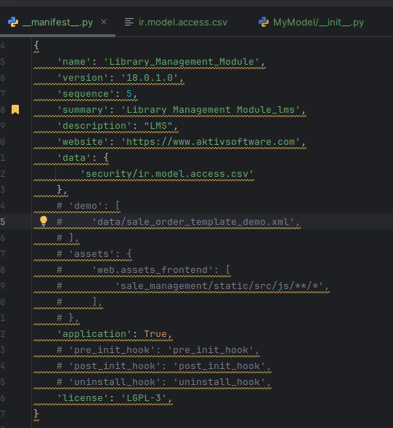

3.Then create your model and inherit the Base Model.

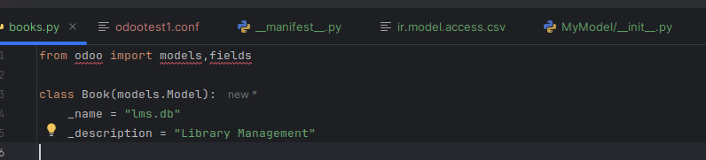

4.Then Install your custom Module using **-i module name.**

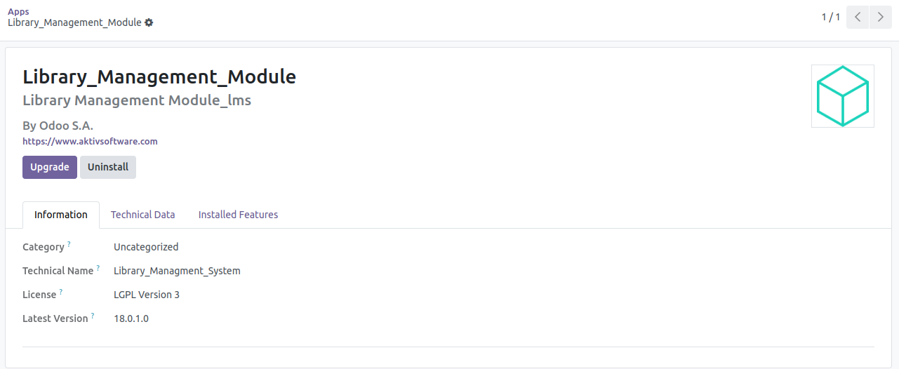

**Manifest File:**

**name (str, required)**

the human-readable name of the module

**version (str)**

this module’s version, should follow [semantic versioning](https://semver.org/) rules

**description (str)**

extended description for the module, in reStructuredText

**website (str)**

website URL for the module author

**license (str, defaults: LGPL-3)**

distribution license for the module. Possible values:

* GPL-2
* GPL-2 or any later version
* GPL-3
* GPL-3 or any later version
* AGPL-3
* LGPL-3
* Other OSI approved licence
* OEEL-1 (Odoo Enterprise Edition License v1.0)
* OPL-1 (Odoo Proprietary License v1.0)
* Other proprietary

**category (str, default: Uncategorized)**

classification category within Odoo, rough business domain for the module.

**depends (list(str))**

Odoo modules which must be loaded before this one, either because this module uses features they create or because it alters resources they define.

When a module is installed, all of its dependencies are installed before it. Likewise dependencies are loaded before a module is loaded.

**data (list(str))**

List of data files which must always be installed or updated with the module. A list of paths from the module root directory

**application (bool, default: False)**

Whether the module should be considered as a fully-fledged application (True) or is just a technical module (False) that provides some extra functionality to an existing application module.